Tan Jia Wei P190458 DISM/2A/02 18.06.2020
Make sure to change username and password in controller/databaseConfig.js!!

Database name: sptravel
SQL Database Tables:
user - to store user information

Column Name | Purpose
userid (Primary Key) | To store a unique userid for the user
username (Unique Index) | username for the user
email (Unique Index) | email for the user
profilepicURL | to store the picture url for the user
createdDate | timestamp for when the row was inserted

travel - to store the travel destination and informations

Column Name | Purpose
travelid (Primary Key) | To store a unique id for the travel record
title | name of the travel record
description | description for the travel record
price | price of the package
travelPeriod | period of the travel

itinerary - to store itinerary for travel destinations

Column Name | Purpose
itineraryid (Primary Key) | To store a unique itineraryid for the record
travelid (Foregin Key) | to store the travelid that this itinerary record is related to
email | email for the user
profilepicURL | to store the picture url for the user
createdDate | timestamp for when the row was inserted

review - to store the reviews of the users for the travel packs

Column Name | Purpose
reviewid (Primary Key) | To store a unique itineraryid for the record
travelid (Foregin Key) | to store the travelid that this review is related to
userid (Foregin Key) | to store the userid that made this review
content | content of the review
rating | review of the rating
createdDate | timestamp for when the row was inserted

itinerary table (travelid) references to travel table (travelid) | CASCADE on delete
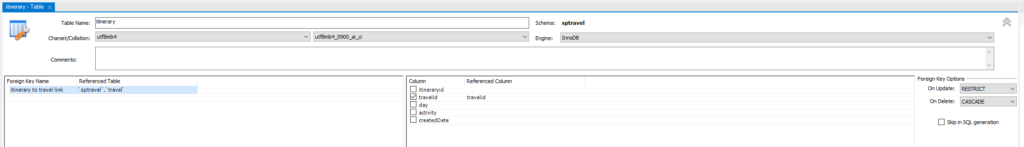

review table (travelid) references to travel table (travelid) | CASCADE on delete
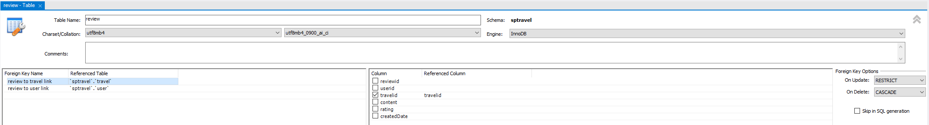

review table (userid) references to user table (userid)
